**Assignment 1**

1. What is JDK? JRE? JVM?

JDK - Java Development Kit. JDK allows developers to create Java programs that can be executed and run by JVM and JRE. A environment for building applications.

JRE - Java Runtime Environment. JRE provides classes and libraries and other resources for developers to execute specific Java programs and applications.

JVM - Java Virtual Machine. JVM is the Java platform component that executes programs. The functions that JVM do is to allow Java program to run on the platform and operating the system, such as managing the memory.

1. What is java compiler?

Java compiler is a program that helps developers to compiles the files that they create to a independent platform of Java file. Make the things in the file to Java language so it will form a Java program.

1. Why is java platform independent?

Java platform is independent because Java uses virtual machine. Java programming languages and APIs are compiled into bytecodes, and Bytecodes are platform independent and the virtual machine will take care of it between different platforms.

1. What is IDE? Why is it important for developers?

IDE - Integrated Development Environment. It allows developers to consolidate the different aspect of writing a computer program. IDEs have their tools and libraries to help programmers more productive by providing common activities such as editing source code, building executable, and debugging.

1. Is java case sensitive?

Java is case-sensitive because it uses a C-style syntax. We use camel casing in Java. For class, we do Testclass. For methods, we do testMethod. When we are writing a function signature, we use public in lower case but cannot do it in upper case (Public). so it is case sensitive.

1. What do the following key words do?  
   static, final, public, private, void, null, package, Class, new

Static - for static variables, it shared by all objects. For static methods, you can just called static methods between two static methods. You can also call using ClassName.methodName.

Final - final variables cannot be changed, final method cannot be override, final class does not allow subclass.

Private - can only accessed inside the same class, cannot access in another class.

Void - it means you don’t have a return value in a void method.

Null - null can be assigned for a variable of the reference class, but not for primitive types of variables. It indicate that a variable does not refer to any objects or array.

Packages - specify what package the class is belongs to.

Class - we use class as a template to create objects and define object data types and methods in a class.

New - we use new to create new objects and data structure in the heap area. The instances of the class.

1. What is primitive type and reference type?

Primitive types are the basic types of data - byte, short, int, long, float, double, boolean, char. Primitive variables store primitive values.

Reference types are any instantiable calss as well as arrays - String, Scanner, Random, int[], String[] and etc. Reference variables store by addresses.

1. Is parameter passed by value or reference?

Java parameters always passed by value.

1. What is the output: System.out.println(1 > 0 : “A”:”B”);

A, because 1 > 0 is true. If its false, it will print B.

1. How to define constants in java?

A constant is a variable for the value that cannot be changed once it has been assigned. But Java doesn't have built in support for constants. We use final and static to assigned variable as a constant value for syntax assigning.

1. What is String? Is it primitive type?

String is not primitive type in Java, it is reference types of data. It is a sequence of characters and we use it widely in Java programming, Strings are object.

1. How to check if a String is representing a number?

We can use Integer.parseInt for a String to check if the string is in numeric. If they contains decimals, we could also change Integer to double and etc.

1. Write a program to implement the following activity diagram:

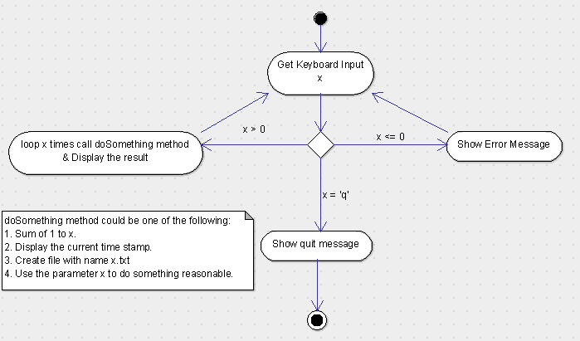

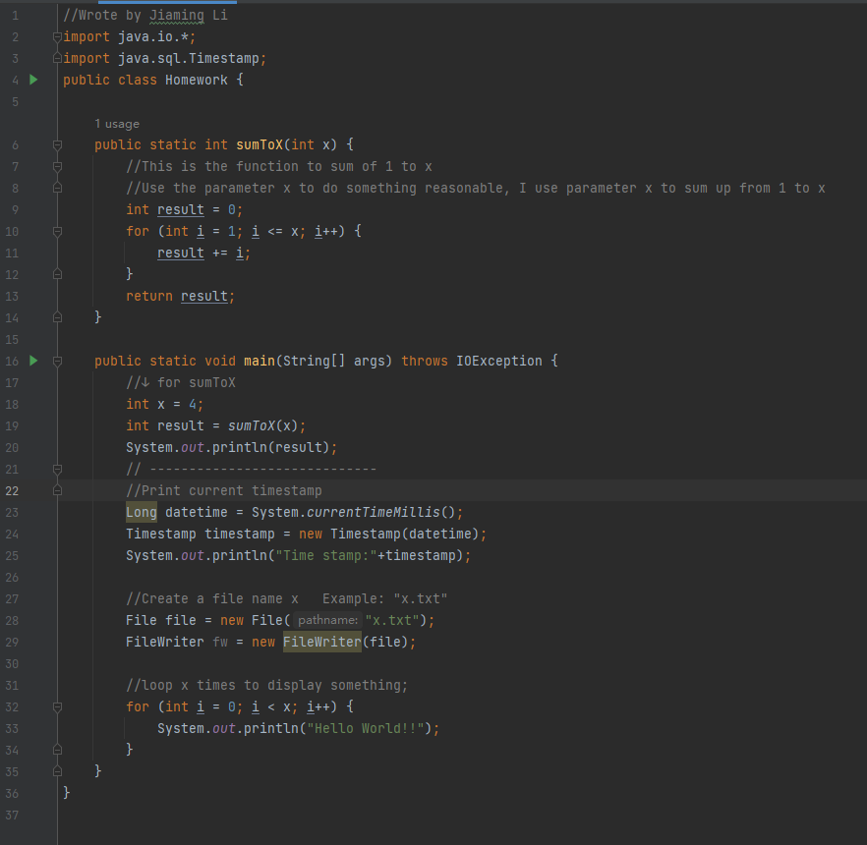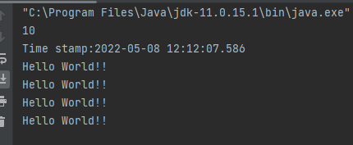

1. Write a program to merge two array of int.

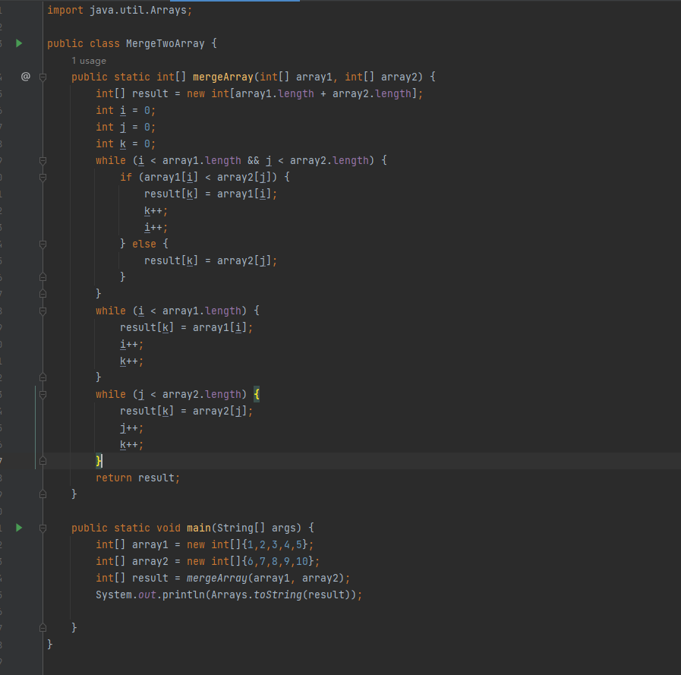

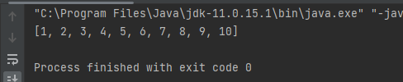

1. Write a program to find the second largest number inside an array of int.

